Feedback for v1.243

Overall
- There is going to be a privacy issue with the Load showing different client scenarios – I don’t want clients to be able to see other client names. Can you suggest a way to overcome this?
- Can we add an export to excel function?
- I tested having only Australian Equities and cash as asset classes in the capital market estimates, and applied a 2% constraint on cash at the entity level – the outcome was quite wrong ie portfolio 10 metrics were return 2.1% and risk 4.0% even though 98% was allocated to Australian Equities. Would you expect this given the way it’s been built or does this need to be reviewed?
- I’m curious why in many outcomes across different scenarios there is a significantly greater allocation to US Small Cap Equities than to Developed World Equities. The difference in expected return is quite modest. Do you know why? Same thing with re High Yield and Emerging Markets Bonds.
Client Details
- The Expected Risk data per asset class should be the same across each entity – should we remove this and just leave the Expected Return?
- Remove the Total data under Expected Return and Expected Risk

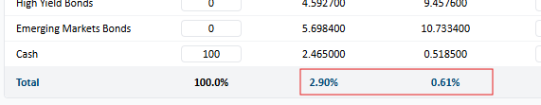
- Can we have a default of 100% allocation to cash?
- Looks like Projection Inputs have reverted back into this section. Can we please move these to the top of the “Projections” tab?
- Can we replace “Constraints (Min %)” with “Tolerance (Min %)” and “Constraints (Max %) with “Tolerance Max%)”
- Can we add another column “Constraints” – this allows asset classes to be selected together with global constraints applied ie I may want a total allocation to Global REITs, Hedge Fund and Commodities of no more than 15% in any combination. This is slightly different to “Tolerance” as it groups asset classes together. Perhaps this could be a tick with the max allocation typed in (I doubt a minimum allocation would be required)

Optimisation
- What happened to the “Pre-tax/post tax” toggle? This was a neat feature
- Do you have metrics for “Forecast Confidence”? ie what does “High (Precise)” actually mean? Is this 9/10 confidence? How is it calculated? When would I not use “High (Precise)”?
- Please remove the descriptive labels for portfolios – they should only have a number
- What is the “Applied 15% Cap to indices: 5,6,7” in the debug?

Output
- The “Asset Allocation” and “Asset Allocation by Entity” data don’t match. Same with the pie charts
- I’m thinking we should remove portfolio 1 as an option as it will never be selected, and rename portfolio 2 as portfolio 1, portfolio 3 as portfolio 2 etc. Effectively there will now be 9 portfolios to choose from. What do you think?
- When I ran a two entity scenario and applied a minimum and maximum constraint of 1% to cash for both entities, the output recommended more than 1% to cash for both entities – please check

Projections
- When toggling from Before to After Tax, can we keep the Wealth Projection chart parameters the same so it doesn’t resize – easier to compare
- Nominal and real button not linked to inflation data box for wealth projection?
- Remove portfolio description
- Under Estimating Outcomes can we show the same time frame as for the Wealth Projection ie if 30 years chosen, then should be for both
- I don’t think the 1 and 2 standard deviation calculations look correct. I would expect a significantly larger downside than upside over time
- Remove “Year” after the year
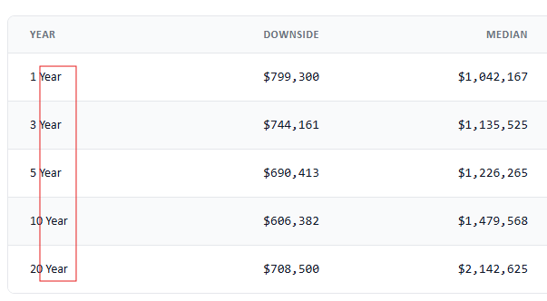

- Change format from all caps to regular
